
Koneru Lakshmaiah Education Foundation
(Deemed to be University estd. u/s. 3 of the UGC Act, 1956)
Off-Campus: Bachupally-Gandimaisamma Road, Bowrampet, Hyderabad, Telangana - 500 043. Phone No: 7815926816, www.klh.edu.in

STUDENT CASE STUDY EXECUTION REPORT
Department | FED
Subject | DSA-2
Academic Year | 1-111 Semester | 2025-26
Faculty Name | Mohd. Razia Alangir Banu
Student Name | P. Yaswanth Surya
Roll Number | 2520030581
Branch | CSE
Course Outcome | CO 2
Case Study Topic: Attendance Database Indexing using B-Tree
Work Done Summary:
In this case study, we implemented a B-Tree data structure for efficient storage and retrieval of student attendance records. The B-Tree was used to organize large attendance datasets and enable fast searching, insertion, and updating of attendance information. We also compared its performance with traditional sequential searching methods.

Implementation Details:
1 Implemented B-Tree insertion and search operations.
2 Stored student attendance records using multi-level indexing.
3 Performed node splitting during overflow conditions.
4 Enabled efficient attendance record retrieval using roll numbers.
5 Updated attendance percentages dynamically.
6 Compared search performance with linear search methods.
• Compared search performance with linear search methods. 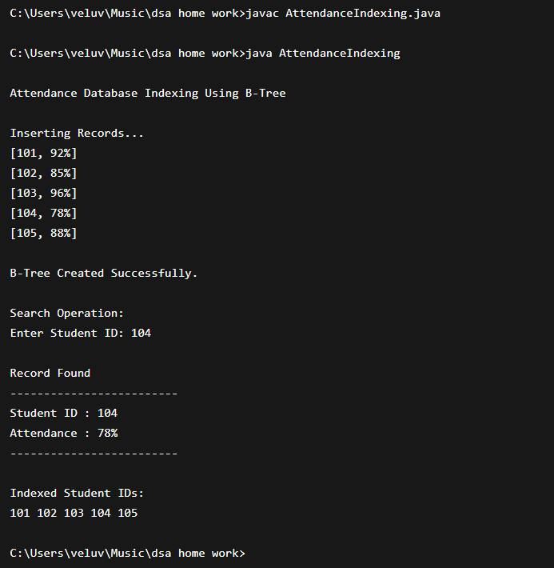

Result: Screenshots / Output
The B-Tree indexed student attendance records efficiently and reduced searching time significantly.
Sample Output:
- Student ID: 220001 → Attendance: 92%
- Student ID: 220015 → Attendance: 88%
- Student ID: 220023 → Attendance: 95%
- Updated Attendance: 90%

Time Complexity:
• B-Tree Search: O(log n)
• B-Tree Insertion: O(log n)
• B-Tree Update: O(log n)

Compared to linear search methods, B-Tree and Segment Tree showed faster performance on large datasets.

GitHub Link: https://github.com/yaswanthsurya-99/DSA-2
Student Signature Faculty Signature

